COMPILER DESIGN LABORATORY
EXPERIMENT 11
LEX PROGRAM TO COUNT UPPERCASE AND LOWERCASE ALPHABETS

AIM
To write a Lex program to read a text file and count the number of uppercase and lowercase alphabetic characters.

ALGORITHM
- Start and initialize uppercase and lowercase counters to zero.
- Open the input text file and check whether it exists.
- Read each character using yylex().
- Increment upper for A–Z and lower for a–z.
- Ignore other characters, including spaces and newlines.
- Print both counts, close the file, and stop.

PSEUDOCODE
START
upper = 0; lower = 0
OPEN input.txt
IF file cannot be opened THEN STOP
WHILE input remains
READ character
IF uppercase THEN upper = upper + 1
ELSE IF lowercase THEN lower = lower + 1
END WHILE
PRINT upper, lower
CLOSE file
STOP

LEX PROGRAM (alphabet.l)
%{
#include <stdio.h>
int upper = 0;
int lower = 0;
%}
%%
[A-Z] { upper++; }
[a-z] { lower++; }
.|\n ;
%%
int main(int argc, char *argv[])
{
if (argc != 2) {
printf("Usage: %s input.txt\n", argv[0]);
return 1;
}
yyin = fopen(argv[1], "r");
if (yyin == NULL) {
printf("Cannot open file!\n");
return 1;
}
yylex();
printf("Uppercase Alphabets: %d\n", upper);
printf("Lowercase Alphabets: %d\n", lower);
fclose(yyin);
return 0;
}
int yywrap() { return 1; }

SAMPLE INPUT (input.txt)
hello LEX
world

EXECUTION COMMANDS
lex alphabet.l
gcc lex.yy.c -o alphabet
./alphabet input.txt

OUTPUT IMAGE
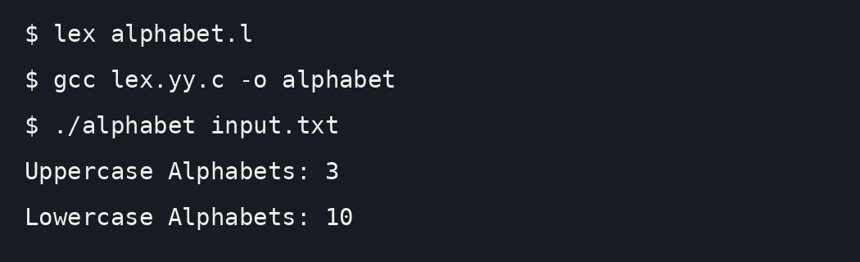
Illustrative terminal output for the sample input.

RESULT
Thus, the Lex program to read a text file and count uppercase and lowercase alphabetic characters was written and the sample output was verified: 3 uppercase and 10 lowercase letters.

